The Lord’s Prayer
Our Father, who art in heaven, hallowed be thy name. Thy kingdom come,
Thy will be done on earth as it is in heaven. Give us this day our daily bread and forgive us our trespasses, as we forgive those who trespass against us. And lead us not into temptation, but deliver us from evil. For thine is the kingdom, and the power, and the glory, forever. Amen.
*Singing Our Faith # 374 “Standing on the Promises”
*Blessing and Dismissal
*Postlude

Scatter to Serve God & Neighbor
Welcome to all! We gather to praise God for the innumerable blessings given
to us and to grow deeper in the Spirit. Joyfully, let us lift our hearts to God.

DIRECTORY OF CHESTNUT HILL UNITED METHODIST CHURCH
Sharma Lewis | Richmond Area Resident Bishop
Denise Bates | Lynchburg District Superintendent
Adam White | Minister
Steve Stadtherr | Associate Minister
Monica Campbell | Administrative Assistant
Heather Wilson | Director of Music Ministry
Judy Martin | Bookkeeper
Judy Robertson | Lay Leader


Chestnut Hill
United Methodist Church

Making disciples of Jesus Christ
for the transformation of the world.
You are welcome at Chestnut Hill UMC.

4660 Fort Avenue ~ Lynchburg, Virginia 24502
Church: 434-239-8423
Minister’s Cell: 434-944-7723, Minister’s Email: awhite@ves.org
Associate Minister’s Cell: 434-841-2458
Associate Minister’s Email: sps83.ss@gmail.com
chestnuthillumc@comcast.net ~ on the web at chestnuthillumc.net
Find us on Facebook: Chestnut Hill United Methodist Church

Chestnut Hill United Methodist Church
10:30 a.m. ~ June 12, 2022 ~ First Sunday after Pentecost ~ Trinity Sunday

Our ministry vision for the Virginia Annual Conference is “to be disciples of Jesus Christ who are lifelong learners, who influence others to serve.”
Welcome! Join us in worshiping God!
Prelude “Here I am to Worship” by T. Hughes
Welcome and Ministry Announcements
Welcome in the name of Christ our Lord. Please register your attendance,
printing your name, address, phone, and email, on the attendance pad provided on your pew. Thank you for silencing cell phones as we gather to worship God.
Invocation
Greeting (Psalm 8)
O Lord, our Lord
how majestic is your name in all the earth!
Your glory is chanted above the heavens by the mouth of bases and infants:
you have set up a defense against your foes, to still the enemy
and avenger.
When I look at your heavens, the work of your fingers,
the moon and the stars which you have established;
what are human beings that you are mindful of them,
and mortals that you care for them?
Yet you have made them little less than God,
and crowned them with glory and honor.
You have given them dominion over the works of your hands;
You have put all things under their feet,
all sheep and oxen,
and also the beasts of the field,
the birds of the air, and the fish of the sea,
whatever passes along the paths of the seas.
O Lord, our Lord,
How majestic is your name in all the earth!

*Singing Our Faith # 61 “Come, Thou Almighty King”
Opening Prayer
Almighty and everlasting God, you have given to us your servants grace,
by the confession of a true faith, to acknowledge the glory of the eternal Trinity, and in the power of your divine Majesty to worship the Unity: Keep us steadfast in this faith and worship, and bring us at last to see you in your one and eternal glory, O Father; who with the Son and the Holy Spirit live and reign, one God, for ever and ever. Amen.
Greeting Friends and Neighbors
Prayer for Illumination
As we are gathered here today, we ask you, our living God, to shower onto us your wisdom and knowledge. We pray that as we listen to your word, we may have the ability to clearly see what God has called us to do. We seek to live to fulfill your purpose so that we can see your kingdom. Illuminate our eyes and reveal to us your glory. Amen.
Scripture Lesson s Romans 5:1-5 and John 16:12-15
The Word of God for the people of God.
Thanks be to God.
Singing Our Faith # 92 “For the Beauty of the Earth”
The Good News “The Just Because-ness of it all”
Special Music “He is Exalted” by T. Paris
Bringing Forward God’s Tithes and Our Gifts
*Doxology # 95 Praise God from whom all blessings flow; praise him, all
Creatures here below; praise him above, ye heavenly host; praise Father, Son, and Holy Ghost. Amen.
*Prayer of Thanksgiving
Sharing of Joys and Concerns

** Calendar **
Monday, 6/13 | 6:30 p.m. | Wesleyan Group  (Meeting at the home of Betty Taylor)
Tuesday, 6/14 | 10:00 a.m. | Staff-Parish Relations Committee
Wednesday, 6/15 |  | Article deadline for newsletter.  We are combining the July/August newsletter.  Please have articles ready for both months.
Thursday, 6/16 – Saturday, 6/18 |  | Virginia Annual Conference  Held in Hampton, Virginia

In the Grocery Cart This Month
For June ~ Cereal.
Place donations in the grocery cart, located in the Commons.



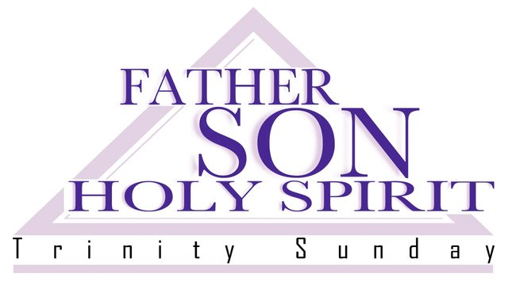

** Calendar **
Monday, 6/13 | 6:30 p.m. | Wesleyan Group  (Meeting at the home of Betty Taylor)
Tuesday, 6/14 | 10:00 a.m. | Staff-Parish Relations Committee
Wednesday, 6/15 |  | Article deadline for newsletter.  We are combining the July/August newsletter.  Please have articles ready for both months.
Thursday, 6/16 – Saturday, 6/18 |  | Virginia Annual Conference  Held in Hampton, Virginia
In the Grocery Cart This Month
For June ~ Cereal.
Place donations in the grocery cart, located in the Commons.

